 | TRAVEL CLUB ltd  Tel: +995 32 2 997999 / +995 32 2921060 / +995 32 2921166  Fax: +995 32 2921383  www.travelclub.ge; www.daisvenet.ge  E-mail: maiko@travelclub.ge, info@travelclub.ge, shorena@travelclub.ge

mogzaurTaklubigTavazobTmogzaurobaswmindamiwaze
saaRdgmoturiiordania-israeli
06.04.2012 – 15.04.2012 (8 Rame/9 dRe)

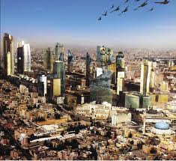
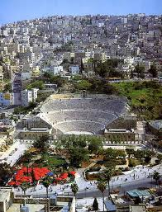
dRe 1 (06.04.2012):TbilisissaerTaSorisoaeroportSiSekreba. gafrena 09:00 TbilisidanamanismimarTulebiTiordaniisaviaxazebisCarteruliaviareisiT. CafrenaamanissaerTaSorisoaeroportSi10:00.savizoformalobebisgavlisSemdegamanissastumroSiganaTavseba. Tavisufalidro.eqskursiaamanSi, herkulesissasaxle, romauliTeatri da Zveliqalaqi. vaxSamisastumroSi.

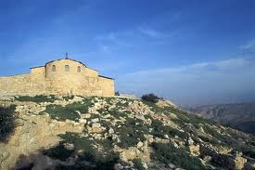
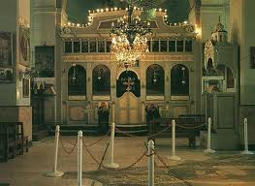
dRe 2 (07.04.2012):sauzmisSemdeggamgzavrebanebosmTaze.
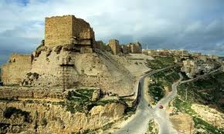
adgilisaidanacufalmamosesaRTqmulimiwadaanaxa.mosesgardacvalebis da gansvenebisadgili, (mosessaflavisadgilicnobiliararis). adgilisadacbabilonistyveobisdrosZveliaRTqmiswinaswarmetyvelmaieremiamaRTqmiskidobanidamala.bizantiurimosnasterismonaxuleba, romliskedlebi da WeriunikaluribizantiurimozaikiTarismopirkeTebuli. gamgzavrebamadabaSi, me-6 saukuniswmgiorgismarTmadidebluritaZarisadacunikalurimozaikiTSesrulebuliierusalimisa da wmindamiwisrukaa, romelicCvenamdeSemonaxuliuZvelesirukaa. gamgzavrebasamefogziTuZvelesqristianulqalaqkarakSi, karakistaZarismonaxuleba. dabrunebaamanSi, vaxSamisastumroSi.

dRe 3 (08.04.2012):sauzmisSemdeggamgzavrebaq.petraSi.
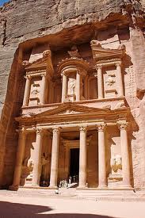
q.petras - “wiTelivardebisqalaqi”- mimarTulebiT.petramsofliosaxalsaocrebaTaganerTerTia. petraagebuliiqnanabatelebismier, romlebicsamxreTiordaniisteritoriazedaaxloebiT 2000 wlis win cxovrobdnen. petrasmacxovreblebiqvazemuSaobisostatebiiyvnen. saxeli “petra”- kldesniSnavs. “elhanzes” (niSnavsganZTamcvels) cnobilimonumentismonaxuleba. ganTavsebaq.petrassastumroSi. vaxSami.

dRe 4 (09.04.2012): sauzmis Semdeg mefe xuseinis xidis Semdeg gamgzavreba israelSi, galileis mimarTulebiT.
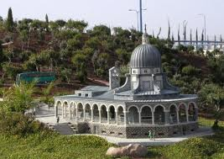
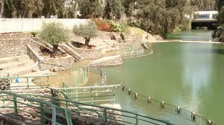
magdala. tabxa - taZari purisa da Tevzis saswaulebrivad gamravlebisa, wm. petres eklesia, Tormeti kapernaumeli mociqulis monasteri, netarebis mTa, mTis qadagebis eklesia sinagoga, magdala – RvTismSoblis dabadebis adgili. befesda.q.beTlemSi gamgzavreba sastumroSi ganTavseba, vaxSami.

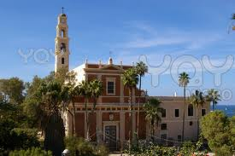
dRe 5 (10.04.2012): sauzmis Semdeg gamgzavreba nazareTSi
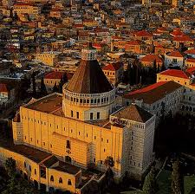
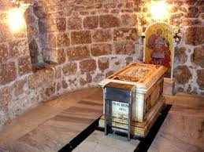
Taboris mTaze asvla. nazareTi – mTavarangeloz gabrielis taZari, ”xarebis” marTlmadidebluri taZari (sadac ecnoba mariams, rom SeeZineboda Ze RvTisa), mariamis Wa, ioseb galileelis saxelosno; galileis kana – (macxovris pirveli saswauli – qorwilSi wylis RviniT gadaqceva)- kanis taZari, iardeniti mdinare iordanes saTave sadac ioane naTlismcemlis mier monaTlul iqna ieso. (SesaZlebelia mdinare iordaneSi ganbanva). gamgzavreba Zvel qalaq lodSi, wm. giorgis taZris daTvaliereba sadac misi wminda nawilebia dasvenebuli.gamgzavreba iafoSi wm. petres eklesia. dabruneba q. beTlemSi sastumroSi. vaxSami sastumroSi.

dRe6(11.04.2012)sauzmis Semdeg gamgzavreba mkvdar zRvaze
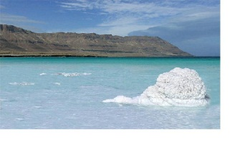
ieriqoni, cdunebis mTis monasteri, zahes xe, Mmkvdari zRვa (Tavisufali dro banaobisTvis), masadas mTa, q.beTlemSi dabruneba, vaxSami sastumroSi.

dRe 7 (12.04.2012): sauzmis Semdeg eqskursia ierusalimSi
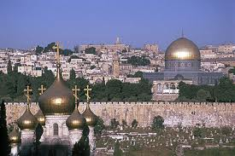
sionis mTa - saidumlo serobis oTaxi, jvris monasteri. geTsimaniis baRi, zeTisxilis mTa, taZari ”mamao Cveno”, ”stopoCka” - macxovris amaRlebis adgili. maria magdalinelis marTlmadidebluri eklesia, RvTismSoblis miZinebis taZari (saflavi), geTsemaniis baRi, katamoni – svimon mirqmelis saflavi. qarTuli jvris monasteri. wminda anas taZari (mariamis deda), befezda (mowyalebis saxli), ”lomis karibWe”, ”via dolorosa” - jvarcmis gza romelic iesom gaiara jvarcmamde macxovris taZari: golgoTa, macxovris saflavi. sastumroSi dabruneba q. beTlemSi vaxSami sastumroSi..

dRe 8 (13.04.2012): sauzmis Semdeg eqskursia beTlemSi
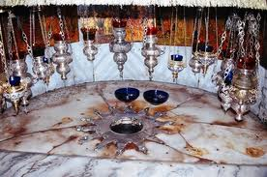
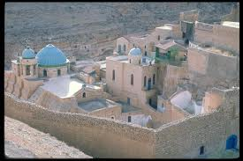
gamgzavreba beTaniaSi: lazares taZari, lazares saflavi, petre pavles kaTolikuri taZari. gamgzavreba beTlemSi: iesos da mefe daviTis dabadebis adgili. qristes Sobis taZari, gamoqvabili ”groto” sadac wminda ojaxi gaCerda gzad egviptisken. wm saba ganwmindelis saflavi, wm sabas lavra, ilia winaswarmetyvelis taZari. ein karemi – ioane naTlismcemlis eklesia, mariamis wyaro, xevroni – mamris muxa. wm. giorgi qozifelis da wm gerasimes iordanelis monastrebi. sastumroSi dabruneba vaxSami.

dRe 7 (14.04.2012) RvTiuri cecxlis gadmosvla
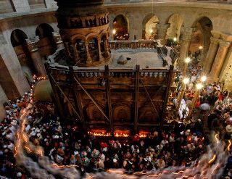
diliT adre gamgzavreba ierusalimSi Zvel qalaqSi macxovris saflavis taZarSi misvla. RvTiuri cecxlis gadmosvla da misi saswaulebrivi miReba. Tavisufali dRe. gamgzavreba iordaniaSi mefe xuseinis xidis gavliT sasazRvro gamSvebi punwtidan q. amanSi.vaxSაmi restoranSi transferi amanis aeroportSi. 15.04.2012 03:00 gamofrena TbilisSi Cafrena 08:00

turis RirebulebaSi Sedis:
- aviabileTi Tbilisi-amani-Tbilisi mimarTulebiT, Carteruli aviareisiT
-sastumroSi ganTavseba orjeradi kvebiT (2 Rame amani/1 Rame petra/5 rame beTlemi)
- transportireba iordaniasa da israelSi
-eqskursiebilicenzirebuli rusulenovani gidis momsaxurebiT
- isrealisvizis Rirebuleba
- iordaniis vizis Rirebuleba
- samogzauro dazRveva.

saWiro sabuTebi:
pasporti da cnoba samsaxuridan

turis Rirebuleba:
4* sastumroSi ganTavsebiT –1250$ erTi adamiani oradgilian nomerSi
5* sastumroSi ganTavsebiT –1550$ erTi adamiani oradgilian nomerSi

(angariSworeba erovnul valutaSi)
sabuTebis miRebis bolo vada 10marti 2012

sastumrumroebi 4* ganTavsebiT:
Amman, Jordan hotels
1.Quality Suites Amman hotelhttp://www.qualityinn.com/hotel-amman-jordan-JO001
2.Ramada Hotel & Suites Hotel http://www.ramada.com/hotels/jordan/amman/ramada-hotel-and-suites-amman/hotel-overview
Petra, Jordan Hotels
1.Panorama Hotel http://www.petrapanorama.com/
2. King’s Way Hotel http://www.booking.com/hotel/jo/golden-tulip-kings-way.en.html
Bethlem, Israel Hotels
- Nativity Hotelhttp://www.nativityhotel.com/

sastumrumroebi 5* ganTavsebiT:
Amman Jordan Hotels
1. Le Meridien Ammanhttp://www.lemeridienamman.com/
2.Landmark http://www.landmarkamman.com/public/English.aspx?Lang=3&Page_Id=564&Menu_ID=98&site_id=3
3. Marriott Amman http://www.marriott.com/hotels/travel/ammjr-amman-marriott-hotel/
Petra Hotels:
1. Marriott Petra http://www.marriott.com/hotels/travel/mpqmc-petra-marriott-hotel/
2. MovenpickPetra http://www.moevenpick-hotels.com/en/pub/hotels_resorts/worldmap/petra/welcome.cfm
Tiberias, Israel Hotels
1. Leonardo hotelhttp://www.leonardo-hotels.com/israel-hotels/tiberias-hotels/leonardo-hotel-tiberias

